Show Notes: Mar 31
Show Notes. [please keep the period at the end and don’t change to a semicolon or the RSS feed won’t work right.]

Update on the Underground War! Gene DUMBs Decode. Over 60 updates! B2T Show Apr 2 (IS) [copy Video Link]

[copy Water with Rick and prepare with Rick from previous Show Notes]

http://healthwithrick.com

Support your health today with Collagen! Click Here! http://www.healthwithrick.com This is my FAV trusted source ^^^^

Secure your family's fortune and get a tax break with a precious metals IRA! Click Here For More Info! http://bit.ly/2zL5Gq1

https://blessed2teach.com/health/

“T-Shirt Store !!

https://twitter.com/Able_Dawn/status/1245444838956433410

https://twitter.com/SITSSHOW/status/1244806108469919744

https://stillnessinthestorm.com/2020/03/researcher-claims-deep-underground-military-bases-recently-destroyed-and-has-some-evidence-to-prove-it/

https://www.amazon.com/s?k=%22deep+underground+military+bases%22&i=stripbooks&ref=nb_sb_noss_2

https://twitter.com/VdarknessF/status/1245173801396166661

https://twitter.com/pierrefroy/status/1245169995685953537

Gene Updates – April 2020
Battle Patriot Protection Prayer
FOR The Truth and Freedom of ALL

People give me your ear those that have been lied to controlled, manipulated and enslaved through oppression and fear, a voice from you soul for deliverance cried; God heard our prayers in his perfect time. God choose a leader and warriors to liberate us with Love and Pride; Where We Go One We Go ALL!
Wars of confusion and hatred we see, all of it orchestrated by a satanic oligarchy; soon we the people will have power restored! God sent anointed a Trump and he replied with a roar and way down inside their souls the people replied to the call; together we stand and united we take back what the devil stole.
Ocean to Ocean, Sky to sky, Mountains to grains, continent to continent, darkness to light the people of The True God have risen and the enemy will be driven to the Judgement halls of Christ!
Books will be written of the Victorious and Brave, tales will be told of a time when the victory was won and the Patriots of man and the Army of God answered God’s call;
Where We Go One We Go ALL!

Philippians 2:10-11
that at the name of Jesus every knee should bow,
in heaven and on earth and under the earth,

Know that the war is achieving great wins for ALL Patriots and the Army of God World Wide:

Children rescued and being cared for in New York (testimonials off hand)
https://soundcloud.com/heath-motley-820983133/nurse-mentions-children-saved

https://soundcloud.com/heath-motley-820983133/nurse-mentions-children-saved
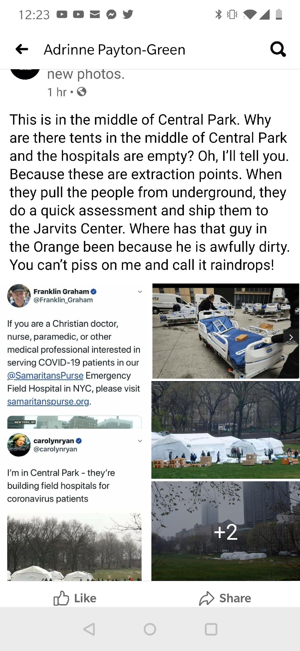

These 2 ships MAY be taking cabal arrested to Gitmo!!
This may be to clear hospital beds for the children rescued and for them to face military tribunals and take responsibility for exactly such things.

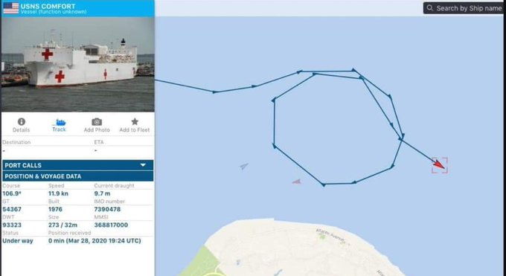

DUMB BATTLE UPDATE!

U.S.
Oklahoma;

Quinton
Time
2020-04-01 18:40:38 (UTC)
Location
35.145°N 95.352°W

Geronimo
Time
2020-04-02 10:28:26 (UTC)
Location
34.538°N 98.345°W

Alaska

Talkeetna

Time
2020-04-02 01:58:34 (UTC)
Location
62.871°N 149.537°W

Yakataga,
Time
2020-03-27 14:17:36 (UTC)
Location
61.125°N 140.535°W

Glennallen,
Time
2020-03-29 17:29:11 (UTC)
Location

Kobuk,
Time
2020-03-27 06:36:17 (UTC)
Location
66.320°N 156.976°W

61.926°N 145.054°W

New York
Time
2020-03-29 17:04:46 (UTC)
Location
43.440°N 78.367°W

Idaho
Time
2020-04-02 13:09:36 (UTC)
Location
44.484°N 115.194°W

Utah
Time
2020-03-28 20:56:59 (UTC)
Location
40.750°N 112.064°W

Oregon
Time
2020-04-01 15:44:24 (UTC)
Location
45.027°N 122.584°W

Canada

Mascouche,
Time
2020-03-29 07:21:04 (UTC)
Location
45.810°N 73.573°W

Dawson,
Time
2020-03-29 06:11:55 (UTC)
Location
64.612°N 138.778°W

Haines Junction,
Time
2020-03-28 03:57:26 (UTC)
Location
60.876°N 138.270°W

Mexico

Alberto Oviedo Mota, B.C.,
Time
2020-04-02 13:24:39 (UTC)
Location
32.262°N 115.291°W

Colombia

Betania,
Time
2020-04-02 03:15:51 (UTC)
Location
5.669°N 76.026°W

Chile

Iquique,
Time
2020-04-02 07:25:06 (UTC)
Location
19.983°S 69.119°W

Argentina

Antonio de los Cobres,
Time
2020-04-01 22:31:52 (UTC)
Location
24.210°S 67.284°W

Japan

Hachinohe,
Time
2020-04-02 09:13:17 (UTC)
Location
40.706°N 143.765°E

Shizunai,
Time
2020-03-28 00:57:52 (UTC)
Location
41.928°N 142.421°E

Papua New Guinea

Porgera,
Time
2020-04-01 14:39:26 (UTC)
Location
6.016°S 142.508°E

Lae,
Time
2020-03-28 04:27:59 (UTC)
Location
6.626°S 146.924°E

Wabag
Time
2020-03-29 02:46:01 (UTC)
Location
5.172°S 144.195°E

Aitape,
Time
2020-04-01 07:49:09 (UTC)
Location
3.259°S 142.479°E

Fiji

Lambasa,
Time
2020-03-27 01:07:53 (UTC)
Location
17.585°S 179.883°E

Tonga
Time
2020-03-27 02:30:22 (UTC)
Location
15.242°S 173.710°W

Hihifo,
Time
2020-03-31 20:33:28 (UTC)
Location
16.643°S 173.563°W

`Ohonua,
Time
2020-03-28 04:34:30 (UTC)
Location
20.720°S 174.274°W

Indonesia

Abepura,
Time
2020-03-27 06:27:19 (UTC)
Location
2.846°S 139.438°E

Sengkang,
Time
2020-03-26 21:58:59 (UTC)
Location
4.098°S 120.038°E

East Timor

Dili,
Time
2020-03-31 08:05:34 (UTC)
Location
7.672°S 127.396°E

China

Qumong,
Time
2020-04-01 12:23:27 (UTC)
Location
33.124°N 98.916°E

Philippines

Baliton,
Time
2020-03-26 15:38:04 (UTC)
Location
5.575°N 125.053°E

India

Chamba,
Time
2020-03-29 18:17:41 (UTC)
Location
32.661°N 76.357°E

Kyrgystan

Korgon,
Time
2020-03-29 04:41:09 (UTC)
Location
41.186°N 72.892°E

Tajikistan

Roshtqal'a,
Time
2020-03-28 01:36:51 (UTC)
Location
37.571°N 72.416°E

Afghanistan
Time
2020-03-30 15:42:33 (UTC)
Location
36.687°N 71.108°E

Farkhar,
Time
2020-03-30 01:49:34 (UTC)
Location
36.096°N 69.950°E

Iran

Sefid,
Time
2020-03-27 06:40:42 (UTC)
Location
28.254°N 57.117°E

Shushtar,
Time
2020-03-27 10:43:43 (UTC)
Location
31.832°N 48.690°E

Mozambigue

Pemba,
Time
2020-04-01 22:18:13 (UTC)
Location
13.137°S 41.036°E

Greece

Lithakia,
Time
2020-03-29 04:34:25 (UTC)
Location
37.221°N 20.578°E

Greenland

Nord,
Time
2020-03-30 14:47:43 (UTC)
Location
82.833°N 27.200°W

Russia

Tiksi,
Time
2020-03-27 23:41:13 (UTC)
Location
72.097°N 127.388°E

The WORLD IS CHANGING NOW!!!
https://youtu.be/7J1xLmoLlSE
sharing the love

Nehemiah 9:27
So you delivered them into the hands of their enemies, who oppressed them. But when they were oppressed they cried out to you. From heaven you heard them, and in your great compassion you gave them deliverers, who rescued them from the hand of their enemies.

Psalm 103:8
The Lord is compassionate and gracious, slow to anger, abounding in love.

Psalm 111:9
He provided redemption for his people; he ordained his covenant forever— holy and awesome is his name.

Romans 3:24
and all are justified freely by his grace through the redemption that came by Christ

DUMB & Tunnel Decode Update Corrections

Sorry for some errors in my update, this was due intel. Confusion.
The current count for DUMBs in The U.S is 206.
Those Underlined are new information and new bases (remember those in italics are under the white hats now):

ALASKA

1. Brooks Range.
2. & 3. Delta Junction & Ft. Greeley: In the same Delta Junction area.
4. Mt. Hayes

ARIZONA

5. Fort Huachuca--31° 50′ N., 110° 119.48” W.
6. Luke Air Force Base.
7. Gates Pass Base.
8. Gila Mountain Area—South of Interstate 8 approx. 30 miles east of Yuma, AZ. 29° N., 116º W.
9. Grand Wash Cliffs—Western edge of the cliffs at the head of Grapevine Wash. Must be reached via Hwy. 93 & then unpaved roads.
10. Green Valley.
11. Hualapai Mountains--East side of the mountain range, about 35 miles. SE of Kingman.
12. Rincon Mtn.—North side of Rincon Mtn.
13. Mt. Lemmon.
14. Page.
15. Safford.
16. Santa Catalina Mountains.
17. Sedona, Arizona—detainment camp: Located under the Enchantment Resort in Boynton Canyon.
18. Wikieup
19. Yucca (Mtns.)—located just off I-40 can easily be seen North of the Hwy., currently has 4 massive large power cables penetrating into the mountain.
20. Sedona

ARKANSAS

21. In the vicinity of Hardy & Cherokee Village—36° 19′ N., 91° 29’ W. Taken under white hat control during hurricane Dorian.
22. Pine Bluff—34° 13.4′ N., 92º 01.0’ W. to 34º 30′ N., 92° 30’ W.

CALIFORNIA

23. Palms Marine Base—Identified on military map as airspace area R-2501 N.: Southeast of Ludlow.
24. China Lake, mind control & weapons research. (Neutralized then destroyed by tactical nuke causing a series of quakes between 6.4 & 7.1 on 8 & 9 July, & California Earthquakes Leave Naval Station China Lake 'Not ...
25. Darwin—4 miles dues West of Darwin city.
26. Deep Springs—37° 22′ N., 117º 59.3′ W.
27. Fort Irwin—35° 20’N., 116° 8’ W.: Detainment camp.
28. Edwards Air Force Base—in the area where Diamond Cr. & the S. fork of the Yuba meet: 34°8′ N., 117° 48′ W.
29. George Air Force Base.
30. Helendale—Lock Head Underground Facility: 34º 44.7′ N., 118.5° W.
31. Los Angeles--On Hwy. 14 towards Edwards A.F.B. after Palmdale: Turn off to 170th street, North on 170th St. to the Rosamond 170th intersection.
32. Mt. Shasta—advanced space technology base, genetic experiments, magnetic advance, space & beam weaponry.
33. Kern River—the hollowed-out mountain next to the hydroelectric facility at the Kern River Project near Bakersfield.
34. Napa Valley—located at Oakville Grade north of Napa: Tunnels also connect the wineries north of Napa, used for white slavery & mind-control,
35. Norton Air Force Base.
36. Quincy—39° 56.2′ N., 120° 56.5′ W.
37. Near Palmdale--take Palmdale Blvd. to 240th St. Go to Ave R-8, at the Eastern limit of Ave. One can see it better from the Three Sisters Hills to the south of the facility. It is involved in hi-tech aerospace technology.
38. Presidio–A FEMA/DOD site for Region IX’s regional office. (Neutralized with underground burn out. Caused fires to be seen in Porter Ranch coming out of manhole covers, see link: Smoke and flames coming up out of sewers in California fires
39. San Bernadino—34º 50′ N. to 34° 16′ N.; was under the entire San Bernadino valley.
Neutralized with tactical nuke—4.5 & 3.2 San Francisco earth quake on 14 Oct.. see Link: Recent Earthquakes in California and Nevada - Index Map
40. Santa Barbara County—placed in the thick diatomite strata.
41. Santa Rosa—38º 26.4′ N., 122º 42.9′ W: FEMA Regional center for the West coast,
42. Sierra Nevada Mountains–very deep base
43. Tehachapi Ranch—Tecachapi Canyon was finished in Sept. ’95. This is the “Unholy 6” base. 35° 20′ N., 118° 40′ W.
44. Trona—35° 45.5′ N., 117º 22.6′ W.–several miles northwest of Trona, directly under Argus Peak. This DUMB sits on China Lake’s NWC’s land, built in the ’60s *(Neutralized with primary China Lake facility. See #15 above).
45. Benicia. (Neutralized with underground burn out. Caused fires to be seen in Porter Ranch coming out of manhole covers, see link: Recent Earthquakes in California and Nevada - Index Map
46. Catalina Island.
47. Chocolate Mountains.
48. Death Valley—entrance to the Death Valley Tunnel is in the Panamint Mountains down on the lower edge of the range near Wingate Pass, in the bottom of an abandoned mine shaft.
49. Lancaster—Aircraft design, anti-gravity engineering, Stealth craft and testing. 42 levels.
50. Lawrence-Livermore International Labs—has the Human Genome Mapping project on chromosome #19 & a newly built $1.2 billion laser facility.
51. Moreno Valley.
52. Morongo Valley.
53. Mt. Lassen.
54. Lancaster
55. Llano.
56. Palmdale—New Aircraft Design, anti-gravity research.. (Neutralized with underground burn out. Caused fires to be seen in Porter Ranch coming out of manhole covers, see link:
Smoke and flames coming up out of sewers in California fires
57. Tehachapi Facility—Northrop, -Tejon Ranch, 42 levels.
58. Ukiah.
59. Kokoweef Peak.
60. Norton AFB.
61. Palmdale—New aircraft design & antigravitics.

COLORADO
62. Alamosa—37° 28.1′ N., 105° 52.2’ W.
63. Book Cliffs—39° 40′ N., 108º 0′ W. near Rifle.58. Boulder–The headquarters for EMC, a type of electro-magnetic mind control broadcast to modify the thinking of Americans, & to control Mk Ultra slaves, genetics, geology/mining as related to tunneling and underground construction.
64. Boulder (vortex)
65. Colorado Springs, NORAD–
66. Fort Collins.
67. & 68. Denver/DIA complex—DIA consists of 5 buildings, 2 of 70 floors.
2 labs destroyed by scientist that gave their lives to stop the release of a Kuru Deep State Dead Man switch in 2012 (required Pena Blvd. to be torn up, to facilitate cleanup, & then rebuilt).
69. Grand Mesa.
70. Montrose--North of Paradox, in Paradox Valley. The site in Paradox Valley can be reached via Hwy. 90 via Nucla.
71. Creede—reached through old mine shafts.
72. Delta.
73. Falcon Air Force Base--Satellite Control.
74. Gore Range Near Lake, West of Denver—Library & Central Data Bank.
75. San Juan Valley--Hidden beneath an operating Buffalo grazing ground.
76. Telluride.
77. Warden Valley West of Fort Collins.
78. Montrose—North of Paradox, in Paradox Valley. The site in Paradox Valley can be reached via Hwy. 90 via Nucla.
79. Grand Junction.

CONNECTICUT
80. N.W. Connecticut.

FLORIDA
81. Pt. St. Lucie—Massive base (taken under white hat control during Hurricane Dorian, see Dorian decodes by Gene & SB2).
82. Eglin AFB--30º 40′ N., 86° 50′ W.

GEORGIA

83.–78. Atlanta–Atlanta has 3 underground installations in its area
84. Thomasville—30° 50.2′ N., 83° 58.9′ W
85. Dobbins Air Force Base, Marrietta

HAWAII

86. & . Ali Manu Crater—under military housing, known as the tunnel, for nuclear weapons storage. Facility underlies ALL of the Island of Oahu & connects to the Island of Hawaii.
Under white hat control since 2017 nuclear missile launch on Hawaii.
82. Hana

IDAHO

87. Lower Goose Lake area in the general area of Oakley
88. South central Idaho–under the Snake River lava flows between Twin Falls & Idaho Falls
Here again look at the earthquakes at the end of 2019!.

INDIANA
89. Bedford & Lawrence area–continued activity in large old mines, indicates a possible government use of the large old quarries.
90. Kokomo.

KANSAS

91. Atchison–the DIPEF underground facility.
92. Fairview—AT & T underground facility.
94. Kinsley
95. Hutchinson—the entrance to the tunnel is underneath Hutchinson Hospital & is huge.
96. Kansas City—Entrance near Worlds of Fun 3.

MARYLAND

98. Camp David
99. Below Ft. Meade, of the National Security Agency—10 acres of the most sophisticated supercomputers that can be built (The Hammer, see SB2 decode).
99. Olney
100. Suitland
101. Edgewood Arsenal

MASSACHUSETTS
102. Maynard--42° 26.0′ N., 71° 27.0′ W

MICHIGAN
103. Battle Creek—42° 19.3′ N., 85° 10.9′ W.: FEMA, regional center, activity secret (not validated).
104. Gwinn—46° 16.8’ N., 87° 26.5′ W.: Large underground base key sending signals. An AFB is nearby.
105. Under Lake Superior—5,000′ deep.

MISSOURI

106. 12 miles South of Lebanon—36° 02.8′ N., 115° 24.3′ W.: Near the newly created town of Twin Bridges.
107. In the Bat/Dry/Dead Man/ Howell cluster of caves.
108. St. Francis Mountains—between St. Louis & New Madrid.
109. Kansas City

MONTANA

110. Montana State University, Bozeman—Genetics.
111. Mount Greenough.

NEBRASKA

112. North-central.
113. Red Willow—near McCook.
114. Kinsley

NEVADA
115. Blue Diamond--36° 02.8’ N., 115° 24.3 W.
116.-120. Groom Lake, also known as Dreamland/Area 51/The Area/the Spot/Red Square/Sally Corridor & Watertown Strip—11° 50’ N., 37° 20' W
AGAIN LOOK AT EARTHQUAKES IN THE LAST 30 DAYS!
121. & 122. Two large underground facilities close to but separate from Groom Lake but controlled by demonic b21ngs--Papoose Range & Cockeyed Ridge (S-4) underground bases.
123.–129. S-2, S-4, S-6, & S-66 underground installations--S-66 is the most secret. 29 levels, 11,300′ deep.
130. Quartzite Mountain—S.E. of Tonopah, 37° 31‘ N., 116° 20’ W.
131. Tonopah--Airforce, C_A deals with secret aircraft.
132. Blue Diamond.
133. Fallon Air Force Base area--the flats, near Reno, "American City".
134. Mercury.
135. San Gabriel--(mountains) On Western side of Mojave.

NEW HAMPSHIRE

136-138. Three underground installations in
New Hampshire’s hills.
Wheel lock park in New Hampshire, DUMB entrance.
Tunnel entrance in dirt pit up to the North west corner sand pit area.
Wheel lock gematria = (Jewish) 1021= High level global elite; Jack the ripper; ATT Soul scalping itself
564 (English) = submerged; Snowden;
Tunnel goes to Monadnock mountain which has a DUMB under it.
Monadnock mountain is part of Monadnock state park.
Monad means; an elementary individual substance which reflects the order of the world and from which material properties are derived
Nock means;
1: one of the notches cut in either of two tips of horn fastened on the ends of a bow or in the bow itself for holding the string
2a: the part of an arrow having a notch for the bowstring
b: the notch itself
Monadnock in Jewish
Gematria equals: 228
Monadnock in English
Gematria equals: 540
Monadnock in Simple
Gematria equals: 90
228 = Meaning of life; Draconian; Look Here;
Battle; Chisamba Obama; Shinar; Coming
Race; Alien Beings; el Gog, and M Gog; 540 &amp; 90 = Spell God; God is here; I am Chiron; Blue Owl el Gog, and M Gog = gog magog war before rapture
Chisamba Obama = Chisamba is an area in
Zambia where 53 people were killed (believed to be by Obama)
Chiron was a Centaur (of spring of Satan)
Shinar = Baal; Molech, Belus; Bei; draconian
1. of the God Draco also 1law : of, relating to, or characteristic of Draco or the severe code of laws held to have been framed by him
2: CRUEL or SEVERE
Portsmouth Naval Shipyard has a DUMB under it that has submarine tunnel to the Connecticut river.-127.

NEW JERSEY

139. Picatinny Arsenal--40° 38’N., 74° 32′ W.: 1/4 cubic mile large & very deep underground.

NEW MEXICO
140. Dulce.
141.–142. White Sands—Alamogordo Area 3 DUMBS.
143. Albuquerque--(AFB).
144. & 145. Datil & Pie Town—Carlsbad Cavern area & another base to the east.
146. & 147. Los Alamos & Taos area facility.
148. Angel Peak—Carlsbad Cavern area (now destroyed), 32° 25.0’ N., 104° 14.0' W.
149.-149. Dulce--36º 56.0’ N., 106° 59.8’ W.
150. Kirtland AFB—Sandia National Lab.
151. Manzano Mtn., near Albuquerque--known as the Kirtland Munitions Storage Complex:
152. Pie Town—34° 17.9’ N., 108° 08.7’ W.
153. Sandia Mountains—NE of Albuquerque.
154. North of Taos Pueblo.
155. White Sands—32° 22.8’ N., 106° 28.8’ W.
156. Cordova
157. Sunspot
158. Sandia mountains—Sandia Labs-Antigravitics, biotissue & hybridization, electron magnetic research, very secret high-tech research (The Jason Group-55 top level scientist; harnessing The Dark Side Technology)
159. Viewtree Mountain.
160. Santa Fe—BATTLE IN PROGRESS (THIS IS THE BEGINNING FOR NEW MEXICO DUMBS!!

NEW YORK

161. Adirondack Mountains—near Elizabethtown.
162. New York Metro area.
163. Plattsburgh--(near Canada and St. Albans) AFB, 49° 40’ N., 73° 33' W.

North Carolina

164. Morganton—In the Brown Mountains

OHIO

165. Wright-Patterson Air Force Base, Dayton—stealth technology & prototype craft.

OKLAHOMA
166. Ada—34° 46.4′ N., 96° 40.7' W.: This base does human cloning, & it is FEMA’s most sensitive base.
167. Ashland Naval Ammunition Depot—34° 45.9’ N., 96° 04.3’ W.
EARTH QUAKE IN THE LAST THIS MONTH, THIS WEEK! FIRST ONE IN THIS AREA IN 80 YEARS! COMPARE THE EARTHQUAKES THIS WEEK TO THE MAPS!

OREGON

168. Bull Run—North side of Bull Run Reservoir area near Mt. Hood, very close to Larch Mtn. & south of Benson St. Park of the Columbia Gorge.
169.-172. Coos Bay area has three separate but coordinating DUMBS.
173. Klamath Falls–since Sept. ’95
174. Cave Junction—--near Hope Mountain. Close to Applegate Lake.
175. Crater Lake.
176. Wimer—(Ashland Mt. area): Underground Chemical Storage Levels.

PENNSYLVANIA

177. Blue Ridge Summit—near Ft. Ritchie, known as ‘Raven Rock” or “Site R”, Army:
178. Raven--(near Ligonier): working back up underground for the Pentagon - sister site of Mt. Weather.

TEXAS
179. Ft. Hood—31° 15’ N., 97° 48′ W.
180. Denton—33° 13.2’ N., 97° 08.2’ W.– FEMA, regional center, activity secret.
181. Red River Arsenal.
182. Calvert.
183. Fort Hood—detainment camp.
184. Fort Stockton.

UTAH

185. Dugway;
186. Kennecott Copper Company.
187. Granite Mountain.
188. Mt. Nebo.
189. Salem.
190. Twin Peaks.

VIRGINIA

191. Bluemont, Mount Weather base
192. Culpepper—38° 28.5’ N., 77° 59.8’ W.: 2 miles East of Culpepper off of Rt. 3.
193. Pentagon, Arlington.
194. Warrington Training Center.
195. Treasure Island Taken control of by white hats during hurricane Dorian (see Dorian decode).
196. Mount Poney—Near Culpepper.

WASHINGTON

197. Mt. St. Helens—electromagnetic, ultra and subsound research
198. Yakima Indian Reservation (Under Toppenish Ridge).
199. Bothell—47° 45.7’ N., 122° 12.2’ W.: FEMA, regional center, activity unknown.
200. Mt. Rainer—underground "vaults" containing records of the ancient Lemurians. (Note: F.L. Boschke wrote the book "The Unexplained" about the mysteries surrounding Mt. Ranier.) The ice cap of Mt. Ranier contains a maze of corridors and caves. In August of 1970, scientists climbed to the top of Mt. Ranier, and entered these caverns and tunnels. Evidence was found indicating that a small lake exists deep beneath the ice cap.

WASHINGTON, D.C.

201. WHITE HOUSE—38° 53.5’ N., 77° 02.0’ W.

WEST VIRGINIA

202. Sugar Grove—the Navy’s Strategic Intelligence Services microwave communications.
203. White Sulphur Springs—under the Greenbriar Hotel

WYOMING

204. Riverton.
205. Confidential: Is currently being fought
for & is too classified to be covered here.

PUERTO RICO

206. San Antonio, Puerto Rico
207. Guanaco, Puerto Rico (Earthquake this week – October 2019)

Canadian DUMBs

- Great Lakes
- Great Lakes Triangle
- Lake Ontario, MONTREAL
- Newfoundland (2 bases)
- Newfoundland (2 bases)
- Ottawa, Toronto
- Calgary, Alberta (under the entire city!)
- Toronto, Canada—There is a small opening to the underground tunnels off Parliament Street in downtown Toronto. The entrance is between two apartment buildings, and leads to the tunnels via the sewers. The underground city beneath Toronto has its center beneath Gerrard Street and Church Street. Above this area, strange magnetic effects have been observed. (Note: This corner of Gerrard & Church streets has a higher accident rate than anywhere else in Toronto. It is believed that underground equipment utilizing powerful magnetic fields (which have caused many strange magnetic effects in houses near this intersection) are responsible for the bizarre equipment failures that often are the cause of these accidents.) The Indians near Toronto have legends of these tunnels.
- The Nahanni Valley—This covers 250 square miles in the southern end of the Mackenzie Mountains of Canada. It lies almost 550 miles due west of Fort Simpson on the Mackenzie River of northwest Canada. Hot springs and sulfur geysers keep the valley warmer than the surrounding areas by about 30 degrees year -round (the valley is above 60 degrees latitude), making it perpetually mist-covered.
- Brooks Range—Area Schwatka Mountains
- Richardson Mountains—Area Mount Hare

Mexico

- Teotihuacan
- Mexico City
- The Liyobaa Cave, Zapoteca Region

England

- Bentwaters
- Meriwith Hill--NSA facility
- Rudloe Manor Wiltshire Just outside of Bath, Southern England
- Staffordshire
- Suffolk

Wales

- Brecon Beacons Wales

Grenada Islands

- Under the islands

Australia

- Pine Gap—Particle and DEW weapons research, genetics, high level black ops. C_A. 13 Floors. Space tracking.
- Mount Ziel
- Canberra
- Snowy Mountains

New Zealand

- Te Anau

Papua New Guinea

- Kokopo

Fiji Islands

- ?

Indonesia

- Saumlaki

New Caledonia

- Isle of Hunter

Russia

- Ramenki—Could hold 120,000 people.
- Yamantan Mountain, Belorelsk area, Southern Urals
- Tundra—Peninsula of Kola
- Siberia—Area Chatanga where the rivers Kotuja and Cheta meet.
- Egveknot,
Sweden

- Gottland Island

Norway

- Narvik
- Finmark--Atomic Energy research

Switzerland

- Mount Blanc

Greenland

- Area Cape Farvel

Africa

- The Nyala range
- West of Kindu

Egypt

- Next to the Libyan border

Iran

- Earthquake during Iraq embassy situation that was under the Iran nuclear power plant 2 miles down.
Malta

- The Maltese Cave

Japan

- Iwo Jima

Albania

- Lshnje

Philippines

- Mindoro, Magsaysay, Davao on the island of Mindanao. Battle in progress. 13th earthquake of 6.1, 6.4 and 6.7, building collapse killing 26 people involved in human trafficking.

North Pole
- NORTH POLE A Regulator of Communication with other Bases
Antarctica

- Admiralty Mountains - Mt. Levick - On top of the Ice. --Weather regulator, Human experiments to make bodies tough. Radio interference, and checking communications of Southern Hemisphere. Highly sophisticated Atomic Reactor. Unconventional Atomic.
- Sör Rondane Mountains.
Iceland

- Jokulsaarglifur National Park

Sweden

- Nordland, on the border
- Norbottens Län

Chile
- Area Río Pico. Latitude about 44 ½ degrees
- North of Arroyo Apeleg.
- Diego De Almagro, Chili
- San Antonio de los Cobre,

Argentina

- Corcovado
- West Side of the Province, Northern part. Area Lago Futalauquen
- Northern part of the Province - Area Villa de Maria
- SAN JUAN - North West from the Province - Area Cerro las Tórtolas--IN THIS AREA THERE ARE TWO BASES
- North of the Maipo Volcano, but less high than the volcano itself.
- Area Cerro Aconcagua on the Argentinean side. TWIN BASES
- Jujuy Province
- Area of Cafayate town
- Area Sierra de Calalasta, North of the Province of Catamarca

Spain

- Mt. Perdido is in the Pyrnees Mountains, between France and Spain --Mt. Perdido, aka Mt. Perdu, is 3,352 m, 11,007 ft. high and is the third highest mountain in the Pyrenees.
- Liyobaa cave

Zambia

- Island of Novoja

Zimbabwe

- Mt. Inyangani, Zimbabwe--It is a tubular grid system ‘for ionizing a layer of air.

Gene Decode
The Underground War – Oct 2019
Greetings Rick, In the Love & Light of The One Infinite Creator!

Below is the New decode on the DUMB system & under Earth War.

PROLONGED SPIRITUAL WAR FOR THE SURVIVAL of EDEN EARTH & HUMANITY

Ephesians 6:12
For our struggle is not against flesh and blood, but against the rulers, against the authorities, against the powers of this dark world and against the spiritual forces of evil in the heavenly realms.

There are 4 stages of this Prolonged Spiritual battle between good & evil or the evil darkness forces that stand opposed to the Divine Plan of The One True Living God & those that have dedicated themselves to the Service of
The ONE True Living God.
The 4 stages necessary to complete in order to win this war against the evil darkness that descended centuries ago on to Earth & attacked Humanity are:
1. Remove the evil darkness from the Space about the Earth and maintain permanent supremacy therein.
2. Remove the evil darkness from Earth’s skies and maintain permanent supremacy therein.
3. Remove the evil darkness from the surface of the Earth and maintain permanent supremacy therein.
4. Remove the evil darkness from the beneath the surface of the Earth (under the Earth’s surface); throughout ALL tunnels, labyrinths, Caverns & DUMBS & maintain permanent supremacy therein.
Stage 1 & 2 have been mostly completed by the Q Alliance patriots & white hats.
Stage 3 has had vast advances by the Q Alliance with only a few strongholds left; mainly being China, Iran & Israel.

Within these countries the Top leadership are now white hat patriots and the swamp draining & removal of Satanic evil upper echelon is proceeding & within the branches of those countries' governments.
In the U.S. the Swamp draining has seen great advances & after the 2Q2Q elections are completed their will be VAST changes occurring, starting with massive arrests & military tribunals and executions for those found guilty of treason (see Mark Taylor prophecy on arrests in Congress).

Stage 4 has now begun.
The massive under Earth war--with the call up of ALL Branches of The U.S. Great Military (10,000 U.S. military in operations at 29 palms; link:
https://www.military.com/daily-news/2019/10/19/unlike-any-exercise-massive-marine-corps-war-game-happening-29-palms.html

the Special Forces leading the vanguard using weapons very few have knowledge of or have ever even dreamed of, is advancing through the immense Illuminati demon forces & vast interconnected Deep Underground Military Bases (DUMBs) complex that is connected with Nationwide Hwys. & tunnels with Magnetic Levitating Trains (MAGLEVS), capable of speed up to 17,000 mph., that connect to all facilities & DUMBS throughout the World.

These facilities have incredible stores of food, water, DNA & seed banks; all fully supplied with autonomous free energy supplies!

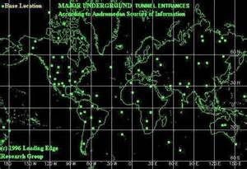
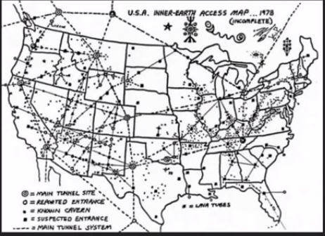

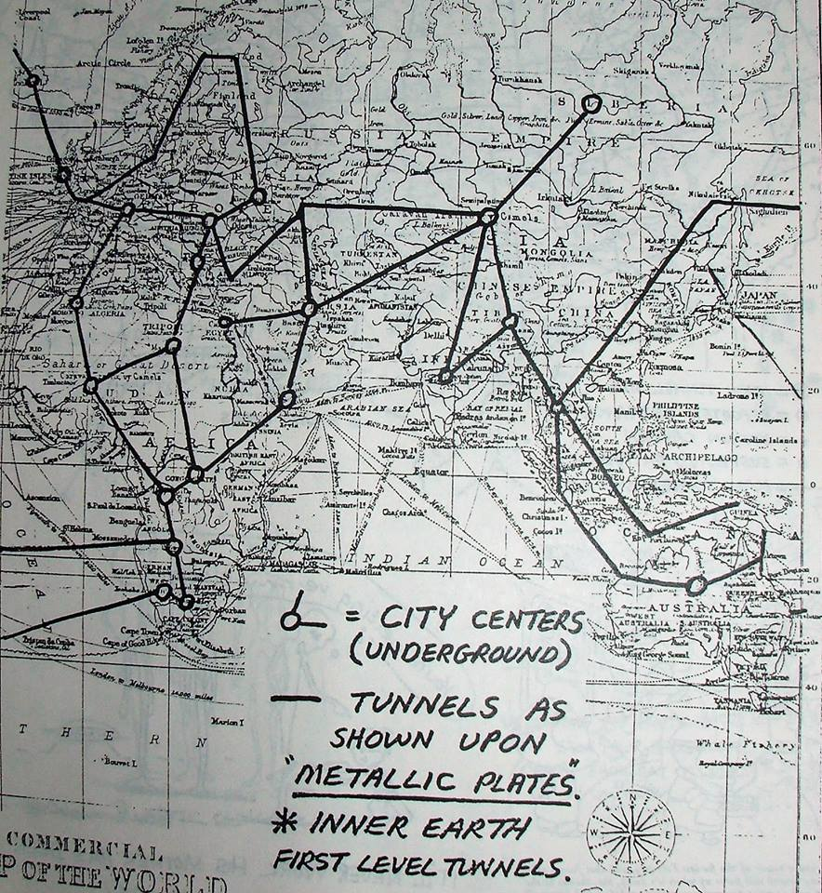
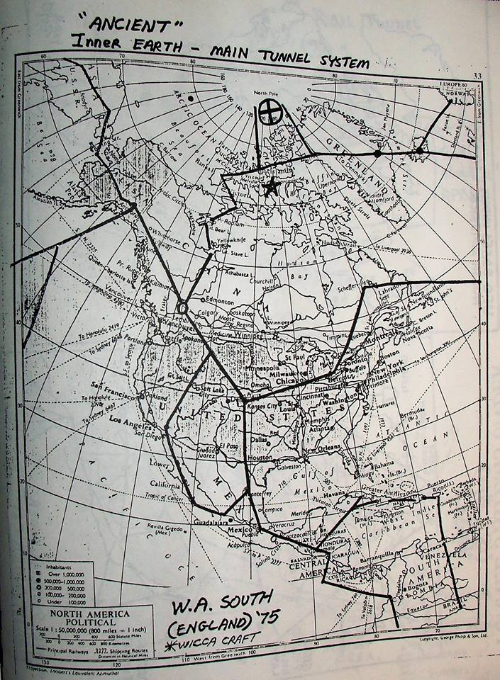

This is the last strong hold of the Satanic Illuminati ancient evil Nephilim bloodlines of Cain.
Evidences of this battle can be seen with fires coming out of sewers, storm hole drains & manhole covers in California (covered on B2T’s show of 13 Oct.). also see link: https://youtu.be/LEPoEsqJAe8

For most of Humanity this Under Earth Network defies the imagination.

This vast Network was created under Project Mk Rand also known as Alternative 2.
In the book entitled Alternative 3, author Leslie Watkins stated scientists concerned with the state of the Earth's atmosphere had secret meetings that produced three alternatives for handling the imminent danger.

Alternative 1: Blast holes through the stratosphere to release heat & pollution. This was done by simultaneous detonations of atomic weapons in the Earth’s high atmosphere of the ozone belt in areas where few would notice: Over Siberia, the deep Amazon, the Australian Outback & over both Poles. This is the cause of the ozone holes (not human ground vehicular and other human causes, as reported by the Fake News Network).
Alternative 2: Relocate the best of Earth's population (compliant slaves & their Illuminati Satanic bloodline masters, in massive underground caverns & DUMBs). Alternative 2 is the DUMB/tunnel network covered in this decode.
Alternative 3: Build bases & major cities of slave laborers supporting the Illuminati Satanic top families on the Moon & Mars.

ALTERNATIVE 2/PROJECT MK RAND
(The name Rand comes from the Rand Corporation which has the patents on the nuclear-powered laser boring machines that bore at over 60 mph)

There are at least 1,400 DUMBS worldwide, 188 known DUMBS in the U.S., with 2 underground bases being built per year in the U.S.
The average depth of bases are 4.25 miles underground. Each DUMB base-costs between 17 & 26 billion $ to build, which is funded by MI6/CIA drug money & human trafficking money.
Each underground base employs 10,000 to 18,000 workers.

Nuclear-powered drills & neutron bombs are the primary methods used to create & dig these DUMBS underground. The drills go through rock at speeds up to 60 mph, literally melting the rock away to form a smooth glass like surface around the edges of the tunnels.
Underground facilities contain computer centers & massive servers, genetic experimentation laboratories, clone mills, mind-control research & control systems & Mk Ultra slave mills & storage facilities; as well as training facilities for those forces, DNA & seed storage facilities, storage of all movies & tv series ever made, fresh water reservoirs, above top-secret weapons & weapons testing & advanced aircraft facilities, gold & financial storage, food storage for survival of millions for 100’s of years, Satanic temples, demonic living areas, fuel storage units, air-conditioning, water reservoirs & large underground lakes, dining & medical facilities, full cities, storage of all movies & tv series ever made, advanced weapon & aircraft & spacecraft research facilities, massive weapon storage bunkers, luxurious resorts, & much more.
The Black Budget is a secretive budget that garners 25% of the gross national product of the United States & currently consumes $1.25 trillion per year--the DUMB projects consume 90% of this.
There are approx. 50 ways tunnels & underground facilities are dug & formed.
Some of these are--high pressure continuous water let, low pressure percussive water jet, high freq. electrical drill, turbine drills, pellet drills, spark drills, explosives both conventional & neutron bombs (these leave no residual radiation), hydraulic rock hammers, lasers, masers, DEW (directed energy weapon beam guns), forced flames, nuclear powered boring machines, dustification guns that break the atomic bonds, to mention a few.

These various tunneling methods can be broken down in:
- Mechanical (such as a water canon)
- Thermal (such as a high velocity flame, laser, atomic fusion, etc.)
- Chemical (such as a dissolver)
- Energy (DEW & other technologies of that type)
The nuclear-powered machines are called Subterrenes (rhymes with submarine). The nuclear Subterrenes build tunnels up to 40’ in diameter; as they work the rock it is melted into a hard, glassy tunnel lining. Fully filtered air-intake shafts bring fresh air to the tunnels & underground facilities. Many of the underground sites are close to railroads, airports, seaports & have entrances trucks can drive into as well as ships & submarines can sail into. Some of the entrances for trucks are protected by holograms that look like the side of a mountain but allow vehicles to just drive through them. The other style of hidden entrances are buildings where trucks drive in and are lowered via access shafts down into the underground areas. Security for facilities vary from Wackenhut to Homeland Security & others. Penetration tests on facilities are carried out by special units called OP-06-D.
LIST OF KNOWN DUMBS in the USA
Underground Bases listed by State
ALASKA
1. Brooks Range.
2. & 3. Delta Junction & Ft. Greeley: In the same Delta Junction area.
ARIZONA
4. Fort Huachuca--31° 50′ N., 110° 119.48” W.: Intelligence training, mind-control, genetics & detention camp.
5. Luke Air Force Base.
6. Gates Pass Base.
7. Gila Mountain Area--South of Interstate 8 approx. 30 miles east of Yuma, AZ. 29° N., 116º W.
8. Grand Wash Cliffs--Western edge of the cliffs at the head of Grapevine Wash. Must be reached via Hwy. 93 & then unpaved roads.
9. Green Valley.
10. Hualapai Mountains--East side of the mountain range, about 35 miles. SE of Kingman.
11. Rincon Mtn.--North side of Rincon Mtn.
12. Mt. Lemmon.
13. Page--goes all the way under Hoover Dam & reservoir.
14. Safford.
15. Santa Catalina Mountains.
16. Sedona, Arizona--detainment camp: Located under the Enchantment Resort in Boynton Canyon.
17. Wikieup
18. Yucca (Mtns.)--located just off I-40 can easily be seen North of the Hwy., currently has 4 massive large power cables penetrating into the mountain.

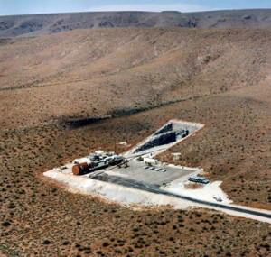
Deep Underground Military Base Yucca Mountain Tunnel Entrance

ARKANSAS
19. In the vicinity of Hardy & Cherokee Village--36° 19′ N., 119° 29’ W. Taken under white hat control during hurricane Dorian.
20. Pine Bluff--34° 13.4′ N., 92º 01.0’ W. to 34º30′ N., 92° 30’ W.
CALIFORNIA
21. 29 Palms Marine Base--Identified on military map as airspace area R-2501 N.: Southeast of Ludlow.
22. China Lake, mind control & weapons research. (Neutralized then destroyed by tactical nukes causing a series of quakes between 6.4 & 7.1 on 8 & 9 July, see links:
See USGS Link: Recent Earthquakes in California and Nevada - Index Map & California Earthquakes Leav e Naval Station China Lake 'Not ...
23. Darwin--4 miles dues West of Darwin city.
24. Deep Springs--37° 22′ N., 117º 59.3′ W.
25. Fort Irwin--35° 20’N., 116° 8’ W.: Detainment camp.
26. Edwards Air Force Base--in the area where Diamond Cr. & the S. fork of the Yuba meet: 34° 8′ N., 117° 48′ W.
27. George Air Force Base.
28. Helendale--Lock Head Underground Facility: 34º 44.7′ N., 118.5° W. Technology for secret projects.
29. Los Angeles--On Hwy. 14 towards Edwards A.F.B. after Palmdale: Turn off to 170th street, North on 170th St. to the Rosamond 170th intersection.
The second lower better maintained dirt road West, right going North at the power lines up to the hilltop, where you will see the top of the underground NORTHOP facility:
Technology for Illuminati secret projects. This facility is near the Tehachapi Mtns. Reported to go down 42 levels. It is heavily involved with electronics & hi-tech aerospace research.
30. Mt. Shasta—advanced space technology base, genetic experiments, magnetic advance, space & beam weaponry; deepest know facility, may over 800 miles deep.
31. Kern River--the hollowed-out mountain next to the hydroelectric facility at the Kern River Project near Bakersfield.
32. Napa Valley--located at Oakville Grade north of Napa: Tunnels also connect the wineries north of Napa, used for white slavery & mind-control,
Direct Satellite Communications, Laser Communications. Continuation of Government site: Located on Oakville Grade, Napa County. 87 Acres.
33. Norton Air Force Base.
34. Quincy--39° 56.2′ N., 120° 56.5′ W.
35. Near Palmdale--take Palmdale Blvd. to 240th St. Go to Ave R-8, at the Eastern limit of Ave. R-8 is McDonnell-Douglas’s facility called the Uano Facility.
One can see it better from the Three Sisters Hills to the south of the facility. It is involved in hi-tech aerospace technology.
36. Presidio–A FEMA/DOD site for Region IX’s regional office. (Neutralized with underground burn out. Caused fires to be seen in Porter Ranch coming out of manhole covers, sewers and storm drains, see link: Smoke and flames coming up out of sewers in California fires
37. San Bernadino--34º 50′ N. to 34° 16′ N.; was under the entire San Bernadino valley.
Neutralized with tactical nuke--4.5 & 3.2 San Francisco earth quake on 14 Oct.. see Link: Recent Earthquakes in California and Nevada - Index Map
38. Santa Barbara County–placed in the thick diatomite strata.
39. Santa Rosa--38º 26.4′ N., 122º 42.9′ W: FEMA Regional center for the West coast, what is being done here mostly kept secret. This is listed as a Communications Antenna Field but is doing much more.
40. Sierra Nevada Mountains–very deep military base.
41. Tehachapi Ranch--Tehachapi Canyon was finished in Sept. ’95. This is the “Unholy 6” base. 35° 20′ N., 118° 40′ W.
42. Trona--35° 45.5′ N., 117º 22.6′ W.–several miles northwest of Trona, directly under Argus Peak. This DUMB sits on China Lake’s NWC’s land, built in the ’60s *(Neutralized with primary China Lake facility. See #15 above).
43. Benicia. (Neutralized with underground burn out. Caused fires to be seen in Porter Ranch coming out of manhole covers sewers & storm drains, see link: Recent Earthquakes in California and Nevada - Index Map
44. Catalina Island.
45. Chocolate Mountains.
46. Death Valley--entrance to the Death Valley Tunnel is in the Panamint Mountains down on the lower edge of the range near Wingate Pass, in the bottom of an abandoned mine shaft.
47. Lancaster--Aircraft design, anti-gravity engineering, Stealth craft & testing. 42 levels.
48. Lawrence-Livermore International Labs--has the Human Genome Mapping project on chromosome #19 & a newly built $1.2 billion laser facility. Chromosome #19 knowledge is primary for cloning, see link: Chromosome 19 abnormalities are commonly seen in AML, M7)
49. Moreno Valley.
50. Mt. Lassen.
51. Needles.
52. Palmdale--New Aircraft Design, anti-gravity research… (Neutralized with underground burn out. Caused fires to be seen in Porter Ranch coming out of manhole covers, sewers & storm drains, see link:
Smoke and flames coming up out of sewers in California fires
53. Tehachapi Facility--Northrop, -Tejon Ranch, 42 levels.
54. Ukiah.
55. Kokoweef Peak – Old mining city
COLORADO
56. Alamosa--37° 28.1′ N., 105° 52.2’ W.
57. Book Cliffs--39° 40′ N., 108º 0′ W. near Rifle.
58. Boulder–The headquarters for EMC, a type of electro-magnetic mind control broadcast to modify the thinking of Americans, & to control Mk Ultra slaves, genetics, geology/mining as related to tunneling and underground construction.
59. Colorado Springs, NORAD–Canada & U.S., & FEMA, hundreds of people on staff, contains at least 4.5 cubic miles of underground caverns & 45 underground steel buildings. This complex tracks thousands of satellites, missiles, submarines, & much more. NORAD also controls many Monarch Mk Ultra slaves who have ALEX, JANUS, ALEXUS end-time callback programming. NORAD installation has 1278 miles of road underground.
(Now under Alliance control & thoroughly cleaned).
60. Fort Collins.
61. & 62. Denver/DIA complex—DIA consists of 5 buildings, the primary 2 have 70 floors. This is 22 miles in diameter at the lowest of the 8 cities under Denver stacked on top of each other! Has facilities for large concentration camp to be used for separation of personal upon martial law after Nuke war starting WWIII.
2 labs destroyed by scientist that gave their lives to stop the release of a Kuru Deep State Dead Man switch in 2012 (required Pena Blvd. to be torn up, to facilitate cleanup, & then rebuilt).
There are acres of fenced-in areas which have barbed wire pointing into the area to keep people in, & small concrete stacks that resemble mini-cooling towers rise out of the acres of nowhere to vent underground levels & exhaust for crematoriums.

The Denver complex is larger than the city above & is meant to be the New D.C. complex. All factors of government are here for transition upon WWIII start.

This is the main hub for ALL U.S. facilities & is tied by MAGLEV trains that average 17,000 mph to ALL other units, World-Wide. Has massive Mk Ultra facilities with many Delta Orion teams with end-time programming.
Storage of all supplies necessary to support 1 million for 150 years. It has a large lake as well as parks with full flora & fauna many miles in diameter, powered by 2 fusion reactors as well as tied to the free energy Earth Tesla grid system. The underground facility goes to 88.3 miles deep & is basically 8 cities on top of each other.

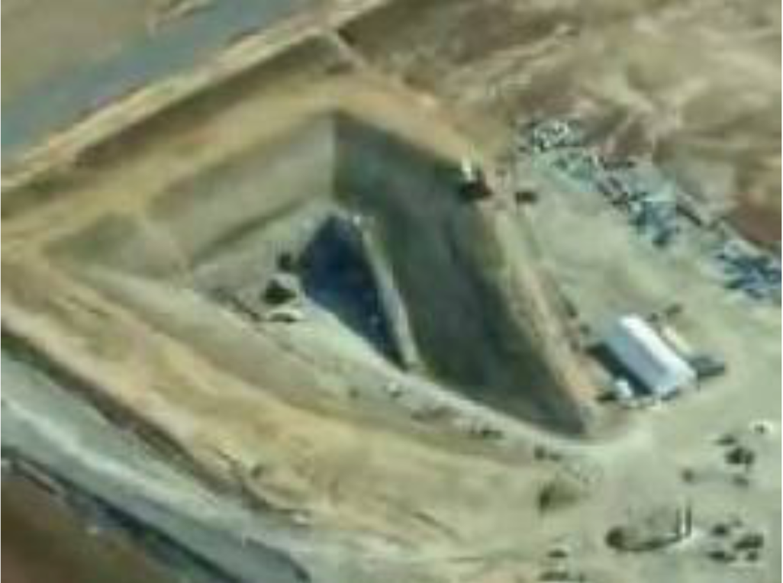
DIA DUMB tunnel entrance
dumbsimages-1
63. Grand Mesa.
64. Montrose--North of Paradox, in Paradox Valley. The site in Paradox Valley can be reached via Hwy. 90 from Nucla.
65. Creede--reached through old mine shafts.
66. Delta.
67. Falcon Air Force Base--Satellite Control.
68. Gore Range Near Lake, West of Denver--Library & Central Data Bank.
69. San Juan Valley--Hidden beneath an operating Buffalo grazing ground.
70. Telluride.
71. Warden Valley--West of Fort Collins.
72. Montrose--North of Paradox, in Paradox Valley. The site in Paradox Valley can be reached via Hwy. 90 via Nucla.
CONNECTICUT
73. N.W. Connecticut.
FLORIDA
74. Pt. St. Lucie--Massive base (taken under white hat control during Hurricane Dorian, see Dorian decodes by Gene & SB2).
75. Eglin AFB--30º 40′ N., 86° 50′ W.
GEORGIA
76.–78. Atlanta–FEMA regional center, placed since Atlanta was to become a capital for one of the 10 regions within the NWO redrawing of boundaries. Atlanta has 3 underground installations in its area:
One to the north at Kennesaw Mtn., Marietta, connected to Dobbins AFB & the one to the South of Atlanta at Forest Park.
79. Thomasville--30° 50.2′ N., 83° 58.9′ W.-- FEMA, regional center, they train groups in Search & Destroy missions (known as Renegade civilian operations).
When Martial Law was to come in America, the UNISF and UNMNTF (United Nations International Security Forces & United Nations Multi-National Task Forces) troops located in DUMBs, in the U.S. & Canada were to be deployed to round up the millions of Americans whose names appear on the C_A Red List & the C_A Blue List. These troops are Chinese, Russian, German, Polish, Japanese, Ukrainian, Saudi Arabian, Pakistani, Mexican, Honduran, Salvadorian, Chilean, Vietnamese, & other foreign trained military Mk Ultra Delta Forces.

The Satanic Cabal Government forces have been involved covertly in the creation of an army of loyal, brainwashed soldiers. They will have cybernetic and microchip implants and will fight anywhere in the world, without question, with total loyalty and without hesitation or fear. These soldiers were created at Brookhaven National Laboratories BNL, the National Ordinance Laboratories NOL and the Massachussetts Institute of Technology MIT, and covertly transferred under DOD and NSA control and planning. Millions of these soldiers were stationed in the Deep Underground Military Bases like the one under Denver International Airport and Thomasville. Additionally, there are millions of UNISF and UNMNTF Troops in America which were brought in under the Partnerships For Peace Program PFPP set up by President Bill Clinton in early 1993.

Mass detentions in FEMA camps & the DUMBs, along with mass executions were planned to occur (see previous Gene decode showing FEMA cars & coffins). A simple search of FEMA camps will show many converted WALMART & converted military bases for this purpose. Current estimates for troop forces that were to be deployed is 6 million.
For example, see link:
Walmart FEMA Camp 'Conspiracy' Is Now 'Fact' - ABC News

80. Dobbins Airforce Base, Marrietta--test site for plasma & antigravity aircraft, experimental crafts & weapons.

HAWAII
81. Ali Manu Crater—under military housing, known as the tunnel, for nuclear weapons storage. Facility underlies ALL of the Island of Oahu & connects to the Island of Hawaii.
82. Hana, HI
Under white hat control since 2017 nuclear missile launches on Hawaii.
IDAHO
83. Lower Goose Lake area in the general area of Oakley–Wackenhut of the Illuminati run a “model prison” for the NWO. The worst of the federal prisoners are placed in this underground prison which has 7,100 cells.
A track runs through the middle of the underground facility. Food & showers are on the tracks, the men are allowed showers once a week.
Minimum of lighting is used; the men are beaten senseless if they talk at all. It sits 500′ underground.
84. South Central Idaho–under the Snake River lava flows between Twin Falls & Idaho Falls.
INDIANA
85. Bedford & Lawrence area–continued activity in large old mines, indicates a possible government use of the large old quarries.
86. Kokomo.
KANSAS
87. Atchison–the DIPEF underground facility.
88. Fairview--AT&T underground facility.
89. Kinsley--Gold stored in huge cavern, blasted shut. Known as the "midway city" because it's located halfway between New York & San Francisco.
90. Hutchinson--the entrance to the tunnel is underneath Hutchinson Hospital & is huge.
91. Kansas City--Entrance near Worlds of Fun 3.
MARYLAND
92. Camp David–just north of the camp is an underground facility important to the intelligence agencies. Under white hat control.
93. Below Ft. Meade, of the National Security Agency--10 acres of the most sophisticated supercomputers that can be built (The Hammer, see SB2 decode).
Very large complex, massive surveillance of all the world’s communications, including all transmissions in the U.S. & world of telephones, telegraph, telex, fax, radio, TV & microwave transmissions. Under white hat control.
94. Olney—Between Olney & Laytonsville, on Riggs Rd. off of Rt. 108. Another underground facility may also exist in the area, possibly FEMA, the facility may be 10 levels deep, purpose unknown.
95. Suitland--Classified archives of U.S. Govt. stored here in underground levels. Vaults have extensive amounts of documents. Restricted access with a coded security card. High level intelligence groups operate in the area also.
In last stage of battle for control.
96. Edgewood Arsenal--Martins AFB, Aberdeen Proving Ground.
MASSACHUSETTS
97. Maynard--42° 26.0′ N., 71° 27.0′ W.: FEMA, regional center, Wackenhut is here too.
MICHIGAN
98. Battle Creek--42° 19.3′ N., 85° 10.9′ W.: FEMA, regional center, activity secret (not validated).
99. Gwinn--46° 16.8’ N., 87° 26.5′ W.: Large underground base key sending signals. An AFB is nearby.
100. Under Lake Superior--5,000′ deep.
MISSOURI
101. 12 miles South of Lebanon--36° 02.8′ N., 115° 24.3′ W.: Near the newly created town of Twin Bridges.
102. In the Bat/Dry/Dead Man/ Howell cluster of caves.
103. St. Francis Mountains--between St. Louis & New Madrid.

MONTANA
104. Bozeman—Genetics.
NEBRASKA
105. North-central.
106. Red Willow--near McCook.
NEVADA
107. Blue Diamond--36° 02.8’ N., 115° 24.3 W.
108.-112. Groom Lake, also known as Dreamland/Area 51/The Area/The Spot/Red Square/Sally Corridor & Watertown Strip--11° 50’ N., 37° 20' W.--Run by the NWO along with demonic beings.
  - The C_A is there & Wackenhut Security. Stealth, cloaking Aircraft research & development. Dreamland (Data Repository Establishment & Maintenance Land), ELMINT (Electromagnetic Intelligence),
  - Biological weapons research & genetic manipulation/warfare storage, Cold Empire, EVA (Electric Vacuum Aspiration), Program HIS (Hybrid Intelligence System), BW/CW; IRIS (Infrared Intruder Systems).
  - Security: Above ground cameras, underground pressure sensors, ground & air patrol.
112. & 113. Two large underground facilities close to but separate from Groom Lake but controlled by demonic beings--Papoose Range & Cockeyed Ridge (S-4) underground bases.
- Purpose is the testing of various secret aircraft like the Aurora (TR3B) & Stealth, also biological work is done. Many levels have been built in three complexes & a 39-mile-long runway has been built over Groom Lake, at dry lake.
115.–121. S-2, S-4, S-6, & S-66 underground installations--S-66 is the most secret. 29 levels,11,300′ deep.
122. Quartzite Mountain—S.E. of Tonopah, 37° 31’ N., 116° 20’ W.
123. Tonopah--Airforce, C_A deals with secret aircraft.
124. Blue Diamond.
125. Fallon Air Force Base area--the flats, near Reno, "American City".
126. Mercury.
127. San Gabriel--(mountains) On Western side of Mojave.
NEW HAMPSHIRE
128-130. Three underground installations in New Hampshire’s hills.
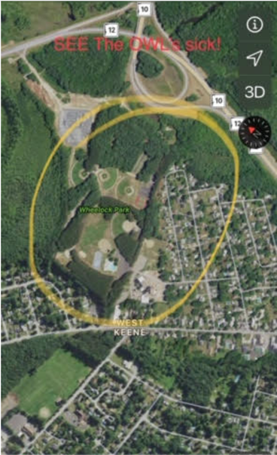
Wheel lock park in New Hampshire, DUMB entrance.
Tunnel entrance in dirt pit up to the North west corner sand pit area.
Wheel lock gematria = (Jewish) 1021= High level global elite; Jack the ripper; ATT Soul scalping itself
564 (English) = submerged; Snowden;

Tunnel goes to Monadnock mountain which has a DUMB under it.
Monadnock mountain is part of Monadnock state park.
Monad means; an elementary individual substance which reflects the order of the world and from which material properties are derived
Nock means;
1: one of the notches cut in either of two tips of horn fastened on the ends of a bow or in the bow itself for holding the string
2a: the part of an arrow having a notch for the bowstring
b: the notch itself

Monadnock in Jewish Gematria equals: 228:m30o50n40a1d4n40o50c3k10
Monadnock in English Gematria equals: 540:m78o90n84a6d24n84o90c18k66
Monadnock in Simple Gematria equals: 90:m13o15n14a1d4n14o15c3k11
228 = Meaning of life; Draconian; Look Here; Battle; Chisamba Obama; Shinar; Coming Race; Alien Beings; el Gog, and M Gog;
540 & 90 = Spell God; God is here; I am Chiron; Blue Owl
el Gog, and M Gog = gog magog war before rapture
Chisamba Obama = Chisamba is an area in Zambia where 53 people were killed (believed to be by Obama)
Chiron was a Centaur (of spring of Satan)
Shinar = Baal; Molech, Belus; Bei;
draconian
1. of the God Draco
also
1law : of, relating to, or characteristic of Draco or the severe code of laws held to have been framed by him
2: CRUE
or SEVERE
Portsmouth Naval Shipyard has a DUMB under it that has submarine tunnel to the Connecticut river.
NEW JERSEY
131. Picatinny Arsenal--40° 38’N., 74° 32′ W.: 1/4 cubic mile large & very deep underground.
NEW MEXICO
132. Dulce – Massive in size
Jicarilla Apache Indian Reservation, under the Archuleta Mesa. Function: Research of mind related functions, genetic experiments, mind control training and reprograming. There are over 3000 real-time video cameras throughout the complex at high- security locations (entrances and exits). There are over 100 secret exits near and around Dulce. Many around Archuleta Mesa, others to the south around Dulce Lake and even as far east as Lindrith.
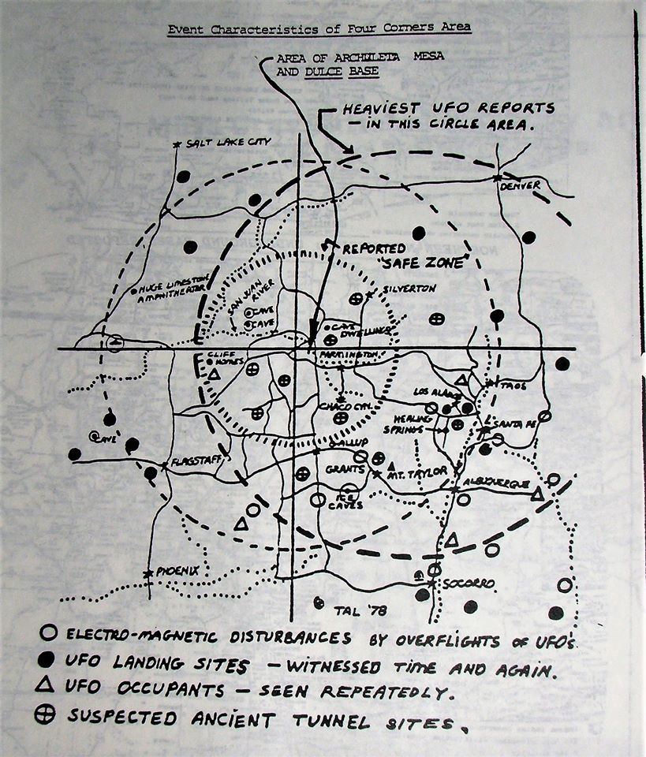
Deep sections of the complex connect into natural cavern systems. Level 1 - garage for street maintenance. Level 2 - garage for trains, shuttles, tunnel-boring machines and disc maintenance. Level 3 - everyone is weighed, in the nude, then given a jump suit uniform. The weight of the person is put on a computer I.D. card each day. Level 4 - Human research in 'paranormal' areas - mental telepathy, mind control, hypnosis, remote viewing, astral traveling - etc. Level 5 - security is severe. Armed guards patrol constantly, weight sensitive areas with handprint and eye print stations. Here, is a device that powers the transfer of atoms. Level 6 - Level 6 is privately called 'Nightmare Hall'. It holds the genetic labs. Experiments done on fish, seals, birds, and mice that are vastly altered from their original forms.
133.–135. White Sands–Alamogordo Area 3 DUMBS.
136. Albuquerque--(AFB).
137. & 138. Datil & Pie Town--Carlsbad Cavern area & another base to the east.
139. & 140. Los Alamos & Taos area facility.
The New Mexico area has four underground systems out.
1. One to the Four Corners area & then to Groom Lake (Area 51).
2. One north toward Delta, CO & Colorado Springs.
3. Taos facility goes north approximately along I-25 & eventually ties in NORAD.
4. The southern bases connect to Texas & Mexico.
The Los Alamos facility dates back to 1940. One can only imagine what has been built with 1/2 century of labor on this underground system.
Visitors to the deeper levels report humans kept in glass cylinders, plus many other strange things--Psychotronic Research, Psychotronic Weapons.
141. Angel Peak--Carlsbad Cavern area (now destroyed), 32° 25.0’ N., 104° 14.0' W.
142.-144. Dulce--36º 56.0’ N., 106° 59.8’ W.: South of Dulce, in the area of the Jicarilla Indian Reservation. The other facility is a few miles East of the Dulce.
- Run directly by Illuminati with Army & Air Force help, C_A also conduct experiments at the center; the size of the installation is huge requiring small shuttle trains. Does biological experiments on humans.
- Wackenhut provides some of the security on the ground.
145. Kirtland AFB--Sandia National Lab.
146. Manzano Mtn., near Albuquerque--known as the Kirtland Munitions Storage Complex: Airforce, 3,000-acre base within the Kirtland AFB/Sandia National Labs complex, guarded by 4 lethal rings of fences.
- A new 285,000-sq. ft. bunker is being built near Manzano Base.
147. Pie Town--34° 17.9’ N., 108° 08.7’ W.
148. Sandia Mountains--NE of Albuquerque.
149. North of Taos Pueblo.
150. White Sands--32° 22.8’ N., 106° 28.8’ W.: Major hub for research, tied in with Dulce & NORAD, HO for NASA /military shuttle flights, radiation research ctr. & mind control.
151. Cordova and also
152. Sunspot

NEW YORK
153. Adirondack Mountains--near Elizabethtown.
154. New York Metro area.
155. Plattsburgh--(near Canada and St. Albans) AFB, 49° 40’ N., 73° 33' W.
OHIO
156. Wright-Patterson Air Force Base, Dayton--stealth technology & prototype craft.
OKLAHOMA
157. Ada--34° 46.4′ N., 96° 40.7' W.: This base does human cloning, & it is FEMA’s most sensitive base.
158. Ashland Naval Ammunition Depot--34° 45.9’ N., 96° 04.3’ W.
OREGON
159. Bull Run--North side of Bull Run Reservoir area near Mt. Hood, very close to Larch Mtn. & south of Benson St. Park of the Columbia Gorge.
160.-163. Coos Bay area has three separate but coordinating DUMBS to a central hub. The facility farthest East, about 20 miles inland in the wilderness near Hwy 42, has been shut down.
It is now an old abandoned facility well camouflaged. The coast facility is probably still operational.
164. Klamath Falls–since Sept. ’95 this has been a base for a number of NWO groups including the Air National Guard, FEMA, C_A, FBI, Spetznaz (Nazi SS) & a MOSAD training base.
- An underground concentration camp exists here (some of the 911 airship crews & passengers believed to be here).
165. Cave Junction--near Hope Mountain. Close to Applegate Lake. Built using abandoned mine with over 36 known miles of tunnels & shafts and over 1500 feed deep.
166. Crater Lake.
167. Wimer--(Ashland Mt. area): Underground Chemical Storage Levels.
PENNSYLVANIA
168. Blue Ridge Summit--near Ft. Ritchie, known as ‘Raven Rock” or “Site R”, Army: Major electronic nerve center, 650 ft. below surface with about 350 staff & over a 716-acre area.
- Connected via tunnel to Camp David. The NOD installation is involved with psychic (demonic) & satellite control over slaves. This underground complex is to allow the government of the United States to escape a nuclear attack.
- The enormous complex radiates under Wash. D.C. and connects with many other sites. The tunnel system is used to move some of the mind-control sex slaves.
- The walls & ceilings of the tunnels are ceramic tile with fluorescent lighting recessed into the ceilings. Battle for control still in progress.
169. Raven--(near Ligonier): working back up underground for the Pentagon - sister site of Mt. Weather. 650' below summit, 4 entrances.
TEXAS
170. Ft. Hood--31° 15’ N., 97° 48′ W.: Home of some Delta Mind-Controlled Mk Ultra Orion link teams.
171. Denton--33° 13.2’ N., 97° 08.2’ W.– FEMA, regional center, activity secret.
172. Red River Arsenal.
173. Calvert.
174. Fort Hood--detainment camp.
175. Fort Stockton
UTAH
176. Dugway; Function: Chemical Storage, Radiation storage.

177. Kennecott Copper Company--connected to the Illuminati & the KKK. Kennecott’s mine--reported to be owned by the World Bank. In the Salt Lake City area is serviced by Union Pacific.
- Reported to be connected to the Mormon Church. The mine is receiving a heavy volume of big trucks after 11 p.m.
VIRGINIA
178. Bluemont, Mount Weather base--Federal Preparedness Agency & FEMA: Small-city underground, top-secret, staff of several hundreds, does secret work for FEMA.
- Contained a complete secret government with the various agencies & cabinet-level ranking administrators that kept their positions for several administrations & ran the United States.
- 176. Culpepper--38° 28.5’ N., 77° 59.8’ W.: 2 miles East of Culpepper off of Rt. 3.
- Illuminati–Fed. reserve, 140,000 sq. ft., includes a facility for the storage for corpses, monitors all major financial transactions in the U.S. by means of the “Fed Wire”, a modern electronic system.
180. Pentagon, Arlington.
181. & 182. Warrington Training Center–two sites: one on Rt. 802 & the other on Bear Wallow Road, on Viewtree Mountain. (Station A the other Station B., purpose unknown).
183. Treasure Island—Nuclear waste & Mk Ultra Orion Delta facility with end-times programming. Taken control of by white hats during hurricane Dorian (see Dorian decode).
184. Mount Poney--Near Culpepper.
WASHINGTON
185. Mt. Rainier.
186. Bothell--47° 45.7’ N., 122° 12.2’ W.: FEMA, regional center, activity unknown.
WASHINGTON, D.C.
187. WHITE HOUSE--38° 53.5’ N., 77° 02.0’ W.–The secret NOD underground installation which is connected to the intelligence groups like the C_A as well as many other nefarious groups.
- Lays under the White House with tunnels connecting this NOD installation with the House of the Temple.
- The Supreme council of the 33° of the Scottish Rite’s House of the Temple has a 14′ x 25′ room in it with 13 chairs where the Illuminati’s Grand Druid Council met. The NOD Deep Underground Installation has numerous levels to it.
Now under white hat control.
WEST VIRGINIA
188. Sugar Grove--the Navy’s Strategic Intelligence Services microwave communications.
189. White Sulphur Springs--under the Greenbriar Hotel: A mini-city large enough for 800 people equipped with its own crematorium.
Links: Fallout Shelters Congress pulled funds for our survival long ago, even sold off most of the old civil defense shelter to private individuals & businesses. Other Nations have underground bunkers for their citizens, but not ours.

A BIT MORE INFO ON GREENBRIER <HERE>, WITH OTHER PHOTOS.

The Greenbrier Facility was intended for the Continuity of Government facility to house the United States Congress, code-named Casper. The bunker is beneath the West Virginia wing, which includes a complete medical clinic. Construction of the facility began in 1959. The steel-reinforced concrete walls of the bunker are 20 feet below ground & are 2 feet thick. The facility includes separate chambers for the House of Representatives & the Senate, as well as a larger room for joint sessions. These are located in the "Exhibit Hall" of the West Virginia Wing, which includes vehicular and pedestrian entrances which can be quickly sealed by blast doors. They don't even hide this one, & it's even a tourist attraction. Greenbrier is a replica of the White House.

WYOMING
190. Riverton \

191. Confdential: Is currently being fought for & is too classified to be covered here.

192. San Antonio, Puerto Rico

Links to DUMB listings by state, see links below:
See the story in its entirety here: Some Underground Bases Listed by State by Don Croft
COMPLETE LIST of Military Underground Bases in USA - The ...
DEEP UNDERGROUND MILITARY BASES - Blogger
dumbsimages-1

This 8-minute video is well worth watching & reveal great inside views of DUMBs:
YouTube
look especially at 4:48- ocean connections too!

There are also many Deep Underground Military Bases under Canada. Almost all of these bases are over 2 miles underground and have diameters ranging from 10 miles up to 30 miles across!
They have been building these bases day and night, unceasingly, since the 1940s.

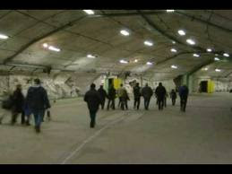
DUMB. Facility

Testimony of James Casbolt:
My name is James Casbolt. I worked in MI6 covert cocaine trafficking operations with the IRA in London between 1995 & 1999. My father Peter Casbolt was also MI6 & worked with the CIA & mafia in Rome in 1993 on covert cocaine & heroin trafficking operations. The global drugs trade run by many factions of the global intelligence community co-operating together (MI6, CIA, MOSSAD etc.) is worth at least £500 billion a year. This is more than the global oil trade.
MI6 controls many of the other intelligence agencies in the world. MI6 created the CIA in 1947 & still control them today. This ‘black ops’ drug money or in classic Orwellian terms, MI6/CIA ’non-appropriated funds’ is being used to fund government and military projects classified ‘Above top secret’.

These operations include a huge worldwide cover up of the building & maintaining of deep underground military bases (DUMBS).

There are many of these bases worldwide but here is small list
1- Under Grenada island
2-Brecon Beacons in Wales
3-Los Alamos in Mexico
4- Pine Gap in Australia
5- The Snowy mountains in Australia
6- The Nyala range in Africa
7- West of Kindu in Africa
8- Next to the Libyan border in Egypt
9- Mount Blanc in Switzerland
10- Narvik in Scandinavia
11- Gottland island in Sweden
12- Teotihuacan in Mexico
13- Mindoro, Magsaysay, Davao on the island of Mindanao. Battle in progress. 13th earthquake of 6.1, 6.4 and 6.7, building collapse killing 26 people involved in human trafficking.
14 – Kokopo, Papua New Guinea
15 – Saumlaki, Indonesia
16- Iwo Jima, Japan
17- Lshnje, Albania
18- Diego De Almagro, Chili
19- San Antonio de los Cobre, Chili
20- Fiji Islands
21- Isle of Hunter, New Caledonia,
22- Te Anau, New Zealand

And many other places (Russia, etc.)
THE WALMART/FEMA CAMP CONNECTION

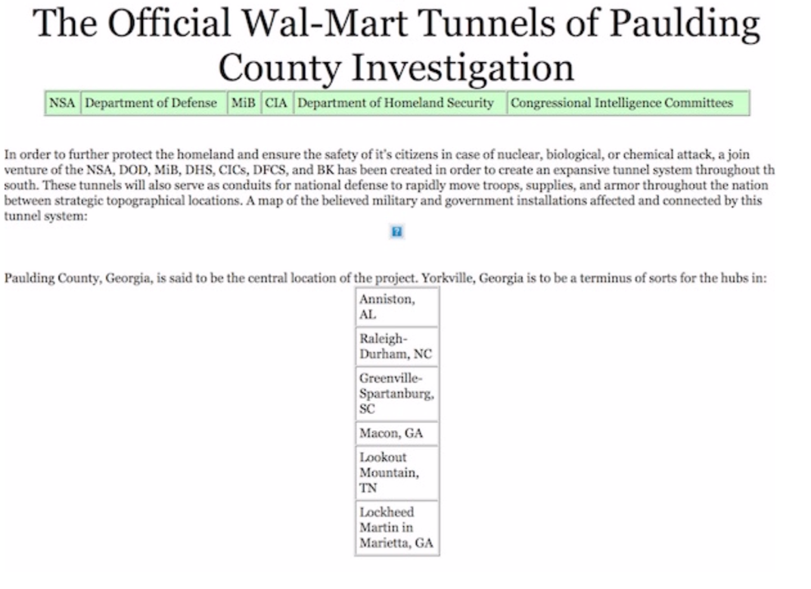
Walmart-1.jpg

Paulding County, Georgia, is said to be the central location of the project. Yorkville, Georgia is to be a terminus of sorts for the hubs.
Wal-Mart's involvement in the project has not yet been officially commented on, but it is generally perceived that Wal-Marts in these areas are staging areas for the tunnel project & FEMA camp personnel holding & Transfer.

Links for DUMBS:

Underground Tunnels and Bases, DUMB | Pearltrees

https://youtu.be/jF86-hl7DlY

YouTubehttps://youtu.be/jF86-hl7DlY

YouTube

See the story in its entirety here: Some Underground Bases Listed by State by Don Croft
Some Underground Bases Listed by State by Don Croft
Feb. 8, 2004. Editor's Note: Phil Schneider used to work for the government and was involved in the construction...

COMPLETE LIST of Military Underground Bases in USA - The ...
DEEP UNDERGROUND MILITARY BASES - Blogger
Underground nuclear power station using self-regulating heat-pipe controlled reactors US 4851183 A
THE ESCAPE FOR THE STARS & PERSONS OF POWER
For Immediate Release: Shelter as Big as the Empire State Building to Save One in Every Million People

'Ark' 2.0: Largest Private Shelter on Earth Prepping Below Kansas Town -...
21st Century Wire | Digging for answers at survival shelter and resort catering to “preparedness minded families...

...
Not just a shelter, but a year-round ‘survival resort’
Atchison, Kansas, June 13, 2013 – A massive underground complex encompassing over 2 million square feet is now being outfitted as the largest private shelter on Earth.
The latest in a network of shelters built by The Vivos Group, this ‘Ark’ is also the first of its kind, being dubbed the Vivos Survival Shelter & Resort

Vivos Survival Shelters - Kansas
Vivos Group, Fractional Villas
Vivos - A global network of hardened, deep underground shelters, built to survive future catastrophes and disast...

THAT'S NICE, YES? A survival time share resort!!
Link about Luxury condo survival units below:
AND THEN THE HUFFINGTON POST PUBLISHED THIS ARTICLE:

How The Super-Rich Plan To Survive The Apocalypse
Most people have too much on their plates to worry about what will happen when the world ends. But then there...

"Super-Rich Plan To Survive Apocalypse In Underground Luxury Condos"
EVEN IRAN HAS BEEN BUSY AS BEES TUNNELING UNDERGROUND.
YES, WE HAVE SPY EYES ON IRAN, NATURALLY!

GOOD SHOT FROM HIGH ABOVE IRAN!
WAY TO GO, TEAM!

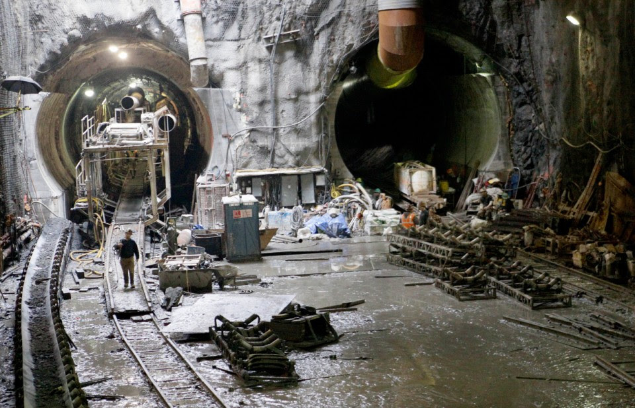
RUSSIAN UNDERGROUND "DEFENCE CITY" BEING BUILT.

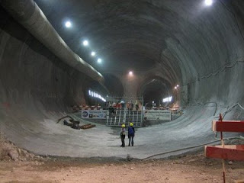

DEEP UNDERGROUND MILITARY BASES IN AMERICA
&
Patents on Boring Machines
US3693731A - patents.google.com

Another Subterrene patent
27 May 1975
See full information of this patent: U.S. Patent No. 3,885,832 dated May 27, 1975

Another Subterrene patent
27 May 1975
See full information of this patent: U.S. Patent No. 3,885,832 dated May 27, 1975

Patent Images

There have been other patents for nuclear powered drilling machines, earlier than the ones shown above:
Nuclear powered drilling method and system US 3280923 A

US3280923A - Nuclear powered drilling method and system - Googl...

Houston, Tex., a corporation of Delaware Filed Sept. 21, 1962, Ser. No. 225,288 8 Claims. (Cl. 175-26). The present invention relates to a nuclear-powered drilling operation and equipment for use therewith.
The entire drilling system is suspendible [SIC] on a nonconductor type cable, which eliminates need for the heavy drill string and permits use of a small, inexpensive drilling rig.
No rotary table is needed in this drilling system, and it generates its own power down-hole for operating the drill bit, for circulating fluid for drilling, and for other operations to be described later in more detail.
At the surface, only a small pump is required to adjust the drilling fluid density and to add mud to the well bore as drilling progresses. High speed round trips to change bits are possible since the only limitation is the horsepower used to operate the cable drum. Finally, because of the simplicity of the surface equipment, only a small operating crew is needed.
The invention encompasses a method for drilling boreholes with a drilling unit containing a drill bit and nuclear power for actuating the drill bit, the steps of which comprise suspending the drilling unit in a borehole on a cable or wire rope; and then actuating said drill bit to drill said borehole deeper while circulating fluid through said drill bit and collect cuttings therefrom in said borehole."
This one is issued just a few days before the Los Alamos second patent:
Apparatus and method for large tunnel excavation in soft and incompetent rock or ground US 3881777 A
Publication number US3881777 A
Publication type Grant
Publication date May 6, 1975
Filing date Jan 25, 1974
Priority date Jan 25, 1974
Inventors John H Altseimer, Robert J Hanold
Original Assignee Us Energy

Patent Citations
Publication numberPriority datePublication dateAssigneeTitle
US3334945A *1964-03-211967-08-08Mott Hay & AndersonTunnelling machine shield having fluid circulating bulkhead and rotary cuting head
US3396806A *1964-07-281968-08-13Physics Internat CompanyThermal underground penetrator
US3667808A *1968-07-091972-06-06Mining Equipment Mfg CorpTunneling machine with tandem spoil barriers
US3693731A *1971-01-081972-09-26Atomic Energy CommissionMethod and apparatus for tunneling by melting
Family To Family Citations
* Cited by examiner, † Cited by third party

Cited By
Publication numberPriority datePublication dateAssigneeTitle
US4167289A *1977-09-291979-09-11Hitachi Construction Machinery Co., Ltd.Method and system for controlling earth pressure in tunnel boring or shield machine
US4171848A *1976-10-131979-10-23Hitachi, Ltd.Control method and system for ensuring stable boring operation at working face during tunnelling with tunnel boring or shield machine
WO2003006792A1 *2001-07-122003-01-23Wirth Maschinen- und Bohrgeräte-Fabrik GmbHHeading and cutting machine for tunnels
Family To Family Citations
* Cited by examiner, † Cited by third party, ‡ Family to family citation

Similar Documents
PublicationPublication DateTitle
US3493165A1970-02-03Continuous tunnel borer
CA2340506C2008-02-26Method and system for mining hydrocarbon-containing materials
EP0042993A11982-01-06Shield tunneling method and machine therefor
CN104695865B2017-04-12Micro tunneling systems and equipment
US7647988B22010-01-19Method and system for installing geothermal transfer apparatuses with a sonic drill
US4655493A1987-04-07Shield tunneling machine
CA2361657C2007-06-26Cutting device
GB1074613A1967-07-05Tunnelling machine and method for constructing a lined tunnel
US3967463A1976-07-06Continuous tunnel boring machine and method
US7832960B22010-11-16All-conditions tunnel boring machine
US3830545A1974-08-20Shield tunneling machine with orbiting cutterhead
KR910002230B11991-04-08Shield tunneling machine
JP2007527493A2007-09-27How to configure the geothermal exchanger
SK50112009A32010-08-09Device to carry out the drillings and method of carry out the drillings
US4726711A1988-02-23Process and apparatus to form an underground passage or space
US3309142A1967-03-14Cutterhead assembly for a shield-type tunneling machine
JP4535981B22010-09-01Panels and tunnel heat utilization heat exchange system for tunnels heat exchanger
CN100532787C2009-08-26Cutter head for cutter head changeable tunnelling machine
US4548443A1985-10-22Tunnel boring machine
US3396806A1968-08-13Thermal underground penetrator
CN1342242A2002-03-27Metal molten drilling method
JP2016026280A2016-02-12Energy extraction system and energy extraction method
CN101289939B2010-11-24Integrated suspension device for retaining a lane for next sublevel
US3916630A1975-11-04Tunneling methods and apparatus
AU761775B22003-06-12Three dimensional multi-phase tunneling method and equipments thereof

Priority And Related Applications

Priority Applications (1)
ApplicationPriority dateFiling dateTitle
US436402741974-01-251974-01-25Apparatus and method for large tunnel excavation in soft and incompetent rock or ground

Applications Claiming Priority (1)
ApplicationFiling dateTitle
US436402741974-01-25Apparatus and method for large tunnel excavation in soft and incompetent rock or ground
[http://atomic-skies.blogspot.com/2012/07/those-magnificent-men-and-their-atomic.html]

The primary tunnel boring unit used; the Nuclear Subterrenes

The Subterrenes melting penetrator head can be of any shape desired.
Cost is $850 million dollars (1970 dollars.
This unit does Rapid Excavation by Rock Melting
Uses molten lithium pumped through a small nuclear reactor & circulated through an annular melting penetrator, reaching temperatures of 1,570º Kelvin,
melting through a ring of rock in front of the machine. The motive power to push the Subterrene through the ground is provided by gravity.
Links:
REUTERS PICKED UP ON THE BILLION DOLLAR PROJECT AGAIN IN 2013, BUT LOOK AT THOSE OLD BREAKABLE DRILL BITS AGAIN!

Billion-dollar drilling project aims for Earth's mantle
Jan. 8 - A Japanese-led project aims to drill to the Earth's mantle, a 3,000 kilometre-thick layer of slowly def...

SUBTERRENES:
In 1972, Robert M. Salter, lead scientist for the Rand Corporation, announced during an interview with LA Times science writer George Getz, that a high-speed system could be built using existing (1972) technologies. He also stated that the system should be built for environmental and economic reasons. What kind of speeds was he talking about?
Over 10,000 MPH! (Read this June 11, 1972 LA Times article).

On August 2nd, 1972, Salter wrote Rand document P-4874. The publication was titled, "The Very High-Speed Transit [VHST] System." The 17-page report detailed the technologies involved, possible attained speeds, aspects of economic and security benefits, and potential routes. This document reported achievable passenger speeds at 14,000 MPH! By 1978, this proposal grew in dimension & attracted serious consideration by Continuity of Government officials, intelligence departments and U.S. military command. That February, Robert Salter submitted report number P-6092, titled, "Trans-Planetary Subway Systems: A Burgeoning Capability." This report updated route maps & extrapolated further upon the economic and technical considerations in planning the system.

Error! Filename not specified.

LA TIMES, JUNE 11, 1972
BEGIN ARTICLE QUOTE"
"L.A. to N.Y. in Half an Hour?
10,000 - M.P.H. Tunnel Train Plan Developed
By: Times Science Writer - George Getz
A Rand corporation physicist has devised a rapid transit system to get you from Los Angeles to NY in half an hour for a $50 fair. He said existing technology made such a system feasible and so does a cost analysis. The essence of the idea is to dig a tunnel more or less along the present routes of U.S. highways 66 and thirty. The tunnel would contain several large tubes for East West travel of trains that float on magnetic fields, moving at top speeds of 10,000 mph. Passengers would face forwarded during acceleration, backward during deceleration. According to R. M. Salter Jr. head of the physical sciences department at Rand, the idea of high-speed train travel using electromagnetic suspension was first put forward in 1905 and actually patented in 1912. The trains he suggested now would be single cars rather than actual trains, and would be big enough to carry both passengers and freight, including large containers and automobiles.
Could Carry Automobiles
The cars, or gondolas, would leave the New York and Los Angeles terminals at one minute or even 30 second intervals. On the main line there would be intermediate stops at Amarillo and Chicago. Feeder lines would meet the main lines at both locations. There would also be subsidiary lines coming into the two main terminals from such cities as San Francisco, Boston and Washington. The main idea of VHST, or Very High-Speed Transit, developed originally in thinking about the satellite program and hyper sonic aircraft speeds." Salter said in an interview at Rand. "The underground tubes were for suggested as alternatives, perhaps not quite seriously, but it was soon apparent that the idea of a tunnel containing such tubes had a lot of real advantages." he said.
Conservation of Energy
In the first place, he explained there is the extremely important matter of the use and conservation of immense amounts of energy needed to move the vehicles at such great speed. "An airplane that travels faster than sound uses up a large part of its available energy supply just in climbing to an altitude where the speeds for which it is designed are possible." Salter said. "That's true of rockets to. Much of their energy is spent and lost forever and getting above the atmosphere." This would not be true for the VHST gondolas traveling on their electromagnetic rail beds, according to Salter. The tubes would be emptied of air, almost to the point of vacuum, so the trains would not need much power to overcome air resistance. They would not even have to be streamlined. In addition to an electromagnetic roadbeds, the opposing electromagnetic loops of wires in the floors of the gondolas would be super cooled with liquid Helium to further eliminate electrical resistance.
Breaking Generates Power
Just as important, the gondolas would, like old-fashioned trolley cars, generate power as they break to a stop. "Since the trains would be leaving New York and Los Angeles simultaneously every minute, the power generated by cars breaking coming into the terminal would be transferred to the power lines propelling the cars going the other way." "For example, there will be halfway points between each stop. Trains would use power and getting to that halfway point, and generate power going the other half of the way to the stop. Each would use power generated by trains going in the other direction." That is the way trolley cars have operated for eighty years - taking power from the overhead lines while accelerating or running along at a steady speed, and putting power back into the lines while breaking or coasting. The big drawback to the Salter scheme is the cost of tunneling across the nation. He admitted that it would be expensive but it does not daunt him. "After the tunneling was finished, everything else would be practically free." He said. Even at the low fair he proposes, the enormous debt created by the tunneling would be amortized within a reasonable period if the number of passengers and the amount of freight came up to Salter's expectations. He figures the tunnel's would carry seven or 8 million tons of freight a day and that passengers would take to traveling back and forth between the Eastern West Coast has readily as they now fly between San Francisco and Los Angeles. "The technology of this is much easier than was developed for the space program."
Salter said. And tunnels, he added, need not be so expensive to dig is people think. The most expensive thing about surface routes is the acquiring right-of-way and removing buildings that stand on the chosen route. The tunnel would not incur this expense. The tunnel, besides carrying tubes for passenger and freight gondolas, would carry many of the utilities now strung across the countryside on high wires. Salter said these underground power "lines" could be super-cooled with helium, like the electromagnetic loops in the floors of the gondolas. He said this would so reduce resistance that power could be transferred from one end of the country to the other without appreciable loss. At the present time long distance transportation of power is difficult because of the amount of energy wasted. He said laser beams could be carried in the tunnel for the instantaneous transmission of messages. Even the mail could go cross-country in pneumatic tubes carried in the tunnel. All this would save money and speed amortization, thus cutting the overall cost of tunneling. Salter said approximately 8000 miles of tunnel were dug in America and Western Europe in the 1960s. That includes mine shafts. But he said existing tunneling technology could be vastly improved. Salter said many tunnels are dug nowadays almost as they would have been in the dark ages. Drilling holes in tunnel faces, and using machines with rotary bits are methods of tunneling that can be improved, according to him. He said the tunnel could be worked on from a great many "faces," for instance. Salter suggested, too, that electronic beams or even water be used to drill holes for blasting. The high-powered electrons would drill blasting holes almost instantaneously.
Travel by Airplane
Projections of future airplane and automobile travels in the United States, and the future train and truck transfer of freight, show that Salter's tunnel idea is not a science fiction fantasy. There will be more room in the tunnels for all the necessary transport than there will be over any feasible number of Airways and freeways and tracks. Salter's suggestion, according to the experts who have had a look at it, is an eminently practical one for handling all the necessary traffic cleanly and without clogging up the air and surface pathways. But it will such a system ever be developed? Salter himself is not optimistic. "Perhaps" is how he puts it. "I am not nearly so optimistic about the political aspects of the problem as I am about our technical capability of doing the job." He said. "History shows that some obviously feasible and practical projects, such as the tunnel proposed over and over again for connecting England and France under the English channel, can be put off for centuries because of political pressure. On the other hand, societies with relatively primitive technology can perform such engineering feats as the erection of impairments." Is the VHS T too far out? Salter suggested that to get the right perspective we should look back 100 years.
Comparison Made
By comparing transportation a century ago and transportation today, one gets a better feel for just how practical VHST is. It appears to be a logical next step, and much more practical than its alternatives of filling the highways and Airways with more and more individually guided vehicles. "This alone is a compelling reason for the high-speed system." Salter said. There are others, according to him. "We can't afford any longer to continue indefinitely to pollute the skies with heat, chemicals, not to mention noise, or to carve up the land with pavement." He said. "We also need to get the trucks and many of the cars off the highway to make the roads available to drivers who drive the family car for fun and convenience."

A FEW OF THE MACHINES, TECHNOLOGIES & PATENTS.

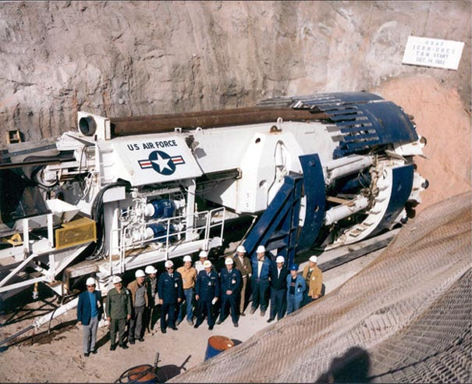
Photo of United States Air Force tunnel boring machine at Little Skull Mountain, Nevada, USA, December 1982.

This is a $13 million tunnel boring machine (TBM) used for tunneling at the Nevada Test Site. (Remember that Area 51 is part of the test site.)
Many other types of TBMs are used by many govt. agencies, including the "nuclear powered TBM" that melts solid rock and leaves behind glass-like walls.
The Mag Lev tubes provide travel at Mach 17 & faster & are connected to a global network of tunnels. There is also an underground highway complex connecting the many DUMBS.
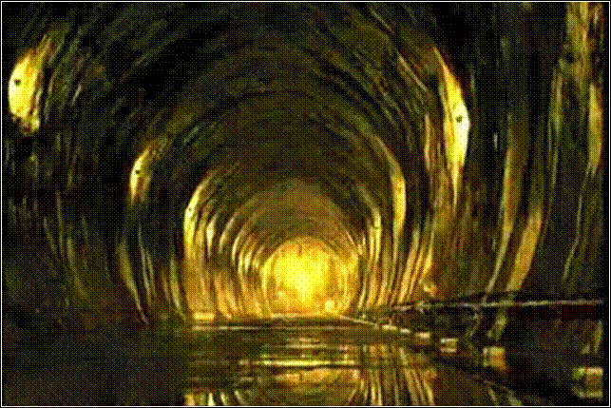

Terradrive tunnel: 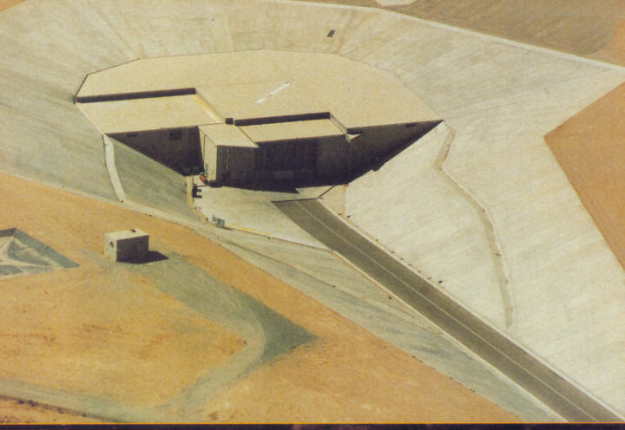

Subterrenes:
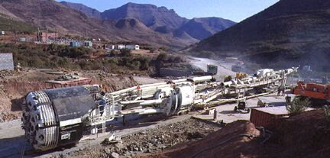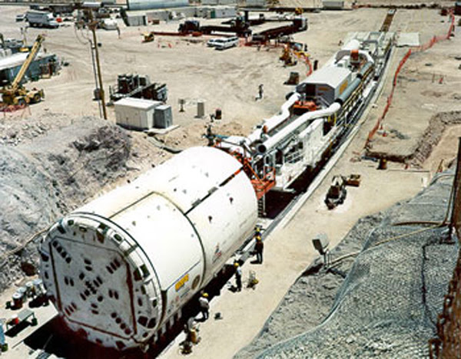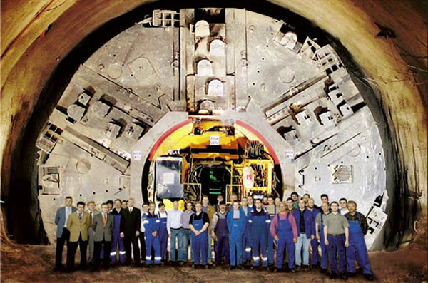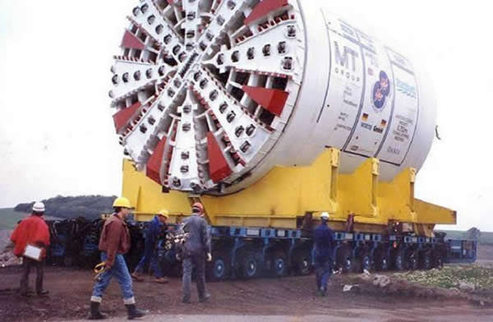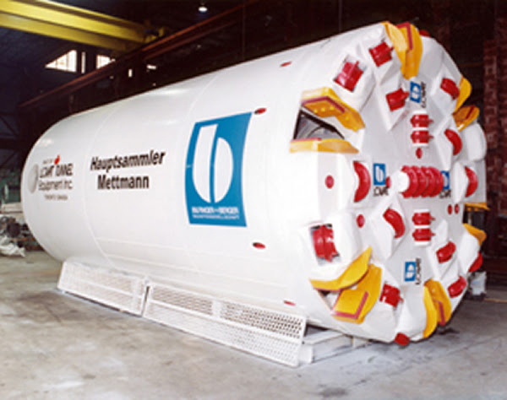

Video on project Subterrne:
YouTube

Great Videos of Truck Drivers In Tunnels & DUMBS:

YouTube

YouTube

Big Bertha largest subterrene:

The Atomic Subterrene
Excursions into the history of atomic energy.

YouTube

YouTube

Truck drivers going into DUMB tunnels links below, just 3:42 long but very enlightening:
Truck Driver Confirms Underground City Beneath US. 2013

Truck Driver Confirms Underground City Beneath US. 2013
Enjoy the videos and music you love, upload original content, and share it all with friends, family, and the wor...

More videos of truck drivers in DUMB tunnel systems:

YouTube

YouTube

https://youtu.be/m-FJGNIpXrg

https://youtu.be/b1YDufouqbY

YouTube

YouTube

For other interesting Links on the DUMBS & tunnels:
The transcript of a 1995 lecture by Phil Schneider, a whistleblower engineer who had helped construct underground bases, and who died a “suicide” in 1996.
For more on Phil Schneider, see projectcamelot.org

Google Image Result for http://projectcamelot.org/phil_schneider.jpg

A Lecture By Phil Schneider
May 1995
Phil Schneider, a very brave man, recently lost his life due to what appeared to be a military-style execution in January 1996. He was found dead in his apartment with piano wire still wrapped around his neck. According to some sources, he had been brutally tortured repeatedly before being killed. Phil Schneider was an ex-government engineer who was involved in building underground bases. He was one of three people to survive the 1979 fire fight between U.S. intelligence & military forces at Dulce underground base.
In May 1995, Phil Schneider did a lecture on what he had discovered. Seven months later he was tortured and killed by those for whom he had previously worked. This man’s final acts should not go unnoticed…
Let us pray for our valiant patriots fighting for our freedom & lives!

Psalm 27:1
“The LORD is my light and my salvation; whom shall I fear? The LORD is the strength of my life; of whom shall I be afraid?”
Psalm 37:39
“But the salvation of the righteous is from the LORD; He is their strength in time of trouble.”
Psalm 138:3
“In the day when I cried out, You answered me, and made me bold with strength in my soul.”

We Pray for strength & for victory of our brave military, may they triumph over this evil! We pray for the safety & victory of our Brave POTUS & His family, for the Patriot Alliance that is saving humanity & the entire Earth!
Finally, we pray that you give all of us; the Army of God; to give us your protection & blessings in surviving this vast conflict, protect us, enlighten us & save us ALL.
We humbly as for these blessing from you;
The One True Living God of All Love Light & Creation
&
In the Name of Your Son
Jesus Christ
We thank you & glory in you Love, Light, Peace & Power
Amen

gene

----------------------------------------------------------------------------------------------------------------------------------------------------------------------------------------------------------------------------------------------------------------------------------------

